**Shashwat Tripathi**

**D10A 58**

**BATCH C**

**UNIX LAB**

**Experiment No: 6**

**VI) Advanced Scripts**

**a) Execute the following scripts using grep / sed commands:**

**(i) Write a script using grep command to find the number of words character, words and lines in a file.**

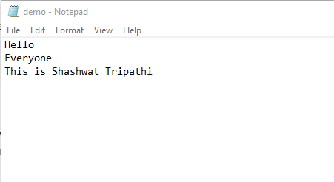

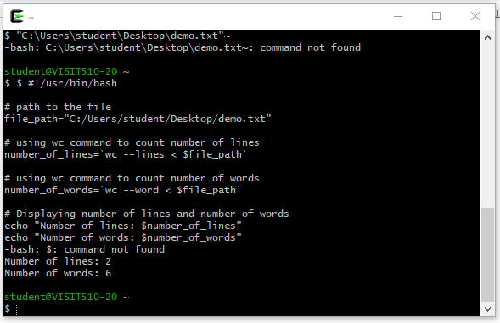

**(iii) Write a script using sed command to replace all occurrences of a particular word in a given file.**

Code:

sed 's/Hello/Goodbye/g' exp6.txt

Goodbye everybody! Shashwat was here!!

Output:

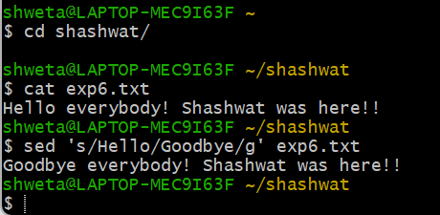

**(iv) Write a script using egrep command to display a list of specific types of files in the directory.**

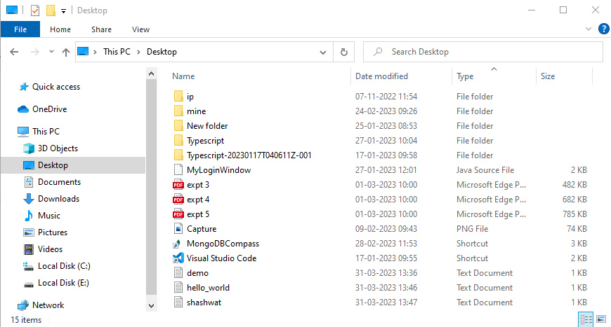

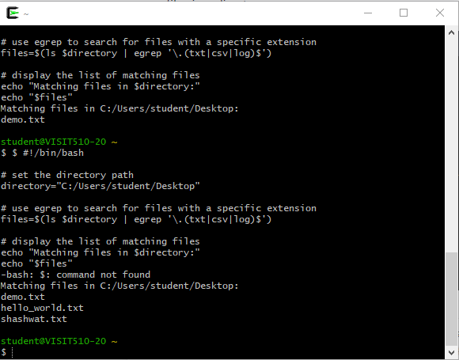

**b) Execute the following scripts using awk / perl languages:**

**(i) Write an awk script to print all even numbers in a given range.**

**Code:**

awk '{for(i=$1;i<=$2;i++) if(i%2==0) print i}' ~/data/input.txt

awk 'BEGIN{for(i=10;i<=20;i++) if(i%2==0) print i}'

**Output:**

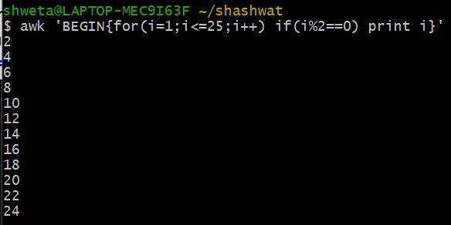

**(ii) Write an awk script to develop a Fibonacci series (take user input for number of terms).**

**CODE-**

awk 'BEGIN{a=0;b=1;print a;print b;for(i=0;i<18;i++){c=a+b;print c;a=b;b=c}}'

**OUTPUT-**

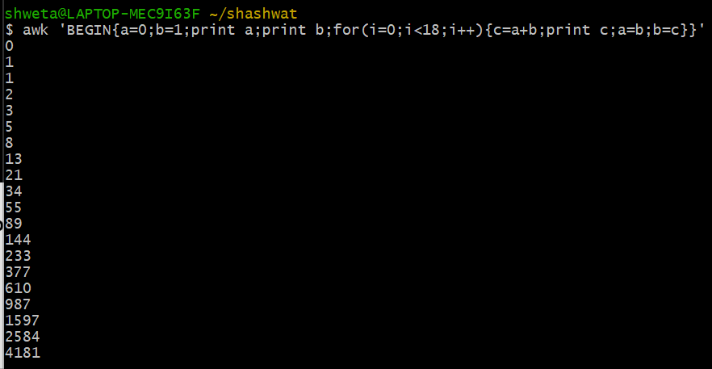

**(iii) Write a perl script to sort elements of an array.**

**Executed on VMWare workstation-**

**Code:**

@numbers = (21, 1, 41, 55, 37, 60, 59);

# Original array

print “Original Array: @numbers\n”;

# Sorting the array

@x = sort {$a ⇔ $b} @numbers;

# Sorted array

print “Sorted Array: @x\n”;

**Output:**

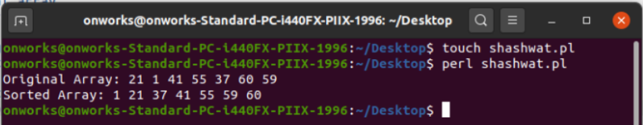

**(iv) Write a perl script to check a number is prime or not.**

**CODE-**

print "Enter a number: ";

$n=<>;

$d=0;

if($n==2)

{

print "Prime number.n";

}

else

{

for($c=2;$c<=$n-1;$c++)

{

if($n%$c==0)

{

$d=1;

break;

}

}

if($d==1)

{

print "Number is not prime!\n";

}

else

{

print "Number is prime!\n";

}

}

**OUTPUT-**

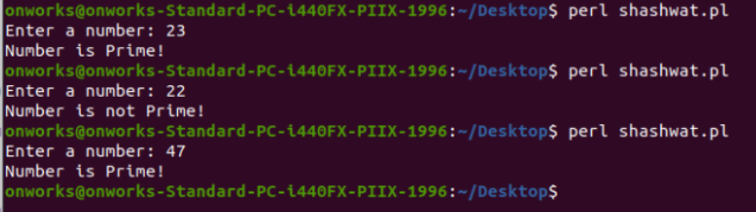

**Shashwat Tripathi**

**D10A 58**

**BATCH C**

**UNIX LAB**

**Experiment No: 5**

**V) Basic Scripts**

**b) (i) Write a shell script to perform arithmetic operations.**

$ echo "Enter 1st number: "

read x

echo "Enter 2nd number: "

read y

echo "Addition of x & y"

echo $(( $x + $y ))

echo "Subtraction of x & y"

echo $(( $x - $y ))

echo "Multiplication of x & y"

echo $(( $x * $y ))

echo "Division of x by y"

echo $(( $x / $y ))

echo "Modulo of x by y"

echo $(( $x % $y ))

Enter 1st number:

35

Enter 2nd number:

5

Addition of x & y

40

Subtraction of x & y

30

Multiplication of x & y

175

Division of x by y

7

Modulo of x by y

0

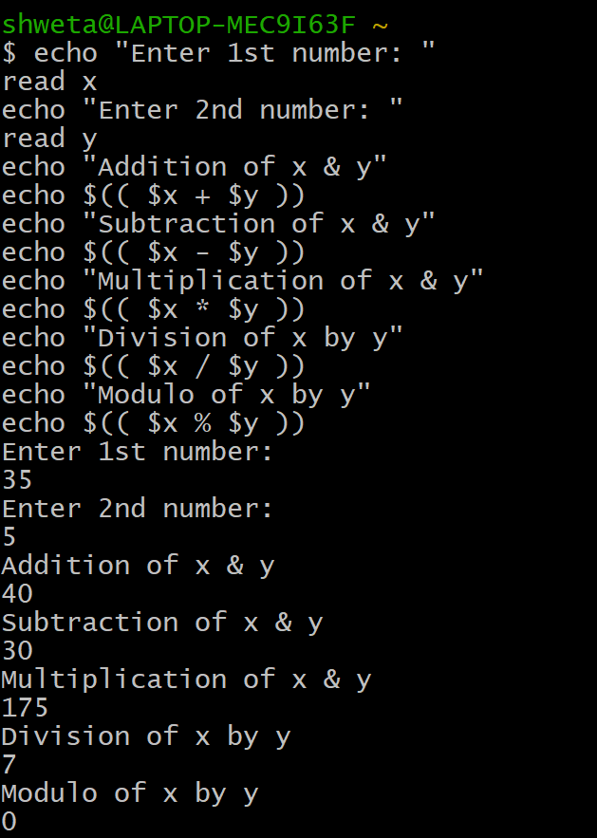

**ii) Write a shell script to calculate simple interest.**

echo "Enter Principle Amount:"

read p

echo "Enter Time period:"

read t

echo "Enter rate of interest:"

read r

si=` expr $p * $r * $t `

si=` expr $si / 100 `

echo "Simple Interest is: $si"

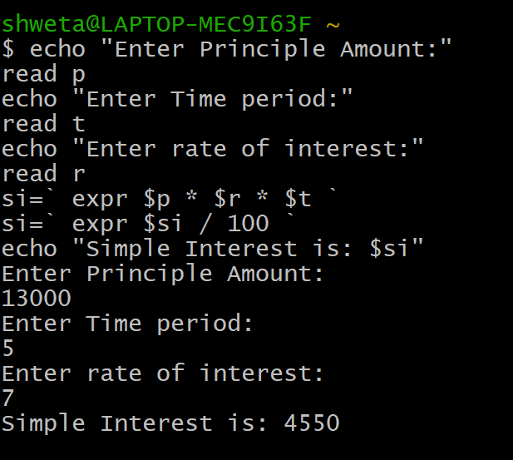

**ii) Write a shell script to determine the largest among three integer numbers.**

**3) if (a>b) ? (a>c ? a : c) : (b>c ? b :c)**

echo "Enter Num1"

read num1

echo "Enter Num2"

read num2

echo "Enter Num3"

read num3

if [ $num1 -gt $num2 ] && [ $num1 -gt $num3 ]

then

echo $num1 is largest

elif [ $num2 -gt $num1 ] && [ $num2 -gt $num3 ]

then

echo $num2 is largest

else

echo $num3 is largest

fi

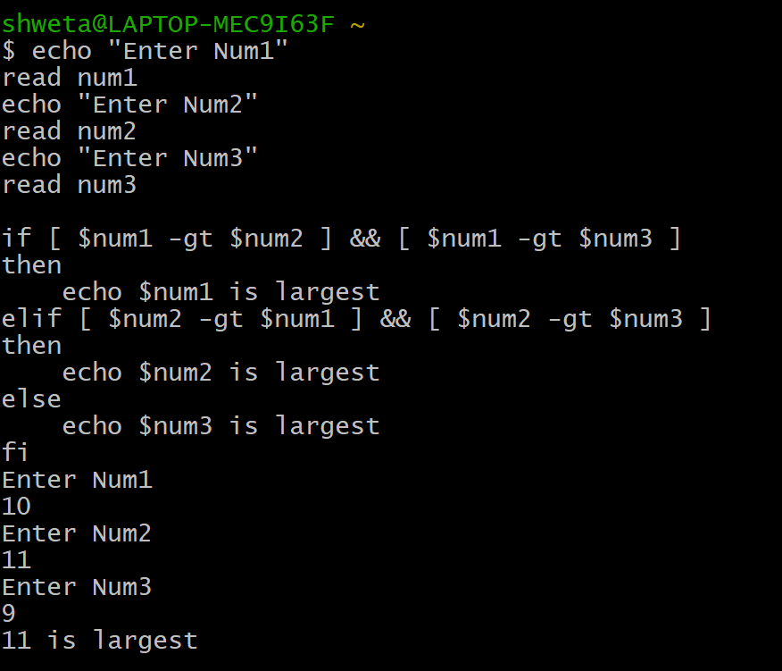

**(iv) Write a shell script to determine a given year is leap year or not.**

echo "TO FIND LEAP YEAR"

echo -n "Enter a year:"

read year_checker

if [ `expr $year_checker % 4` -eq 0 ]

then

echo "$year_checker is a leap year"

else

echo "$year_checker is not a leap year"

fi

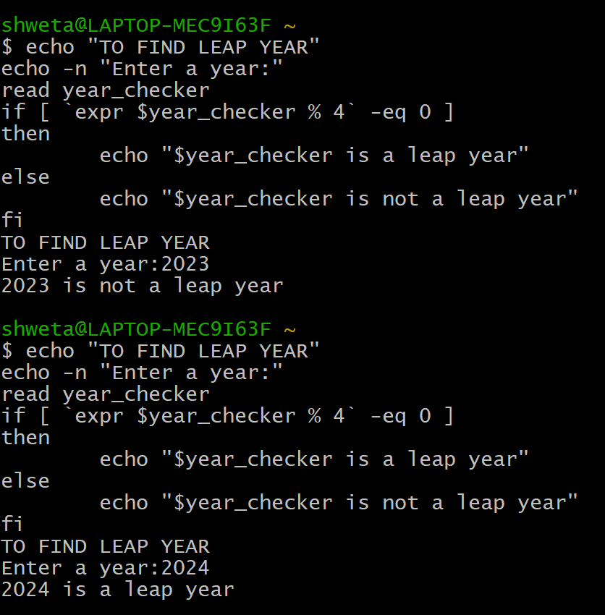

**v) Write a shell script to print multiplication table of**

**given number using while statement.**

echo "Enter the number -"

read n

i=1

while [ $i -le 10 ]

do

res=`expr $i \* $n`

echo "$n * $i = $res"

((++i))

done

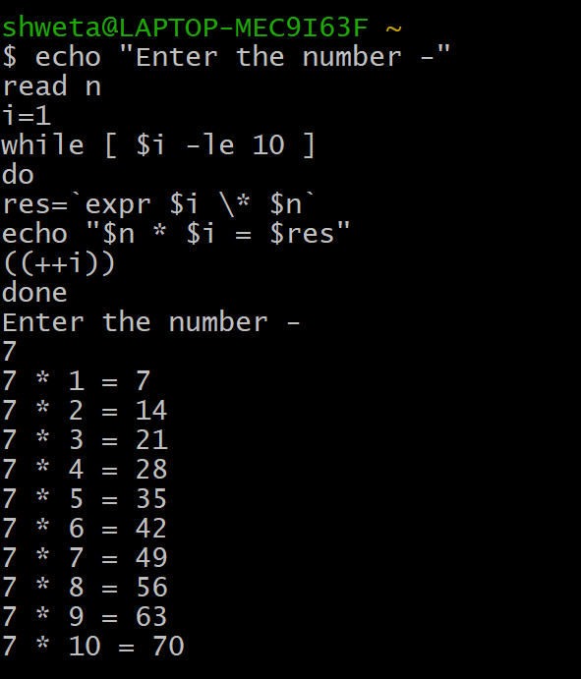

**vi) Write a shell script to compare two strings.**

read -p "Enter two strings: " str1 str2

if [ $str1 == $str2 ]

then

echo "Strings are Equal"

else

echo "Strings are Unequal"

fi

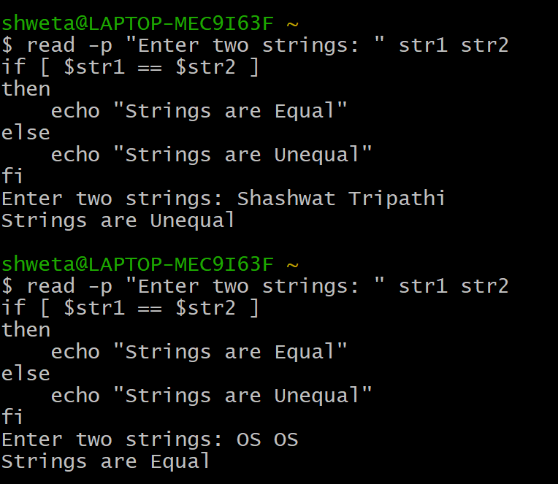

**Shashwat Tripathi**

**D10A 58**

**BATCH C**

**UNIX LAB**

**Experiment No: 4**

**IV) Commands for Process Management and Memory Management**

1. **Process Management**
2. **ps-**  ps command is used to list the currently running processes and their PIDs along with some other information depends on different options. It reads the process information from the virtual files in **/proc** file-system. /proc contains virtual files, this is the reason it’s referred to as a virtual file system.

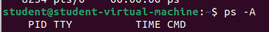



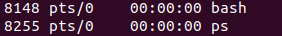

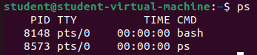

1. **pstree**- **Pstree** command in Linux that shows the running processes as a tree which is a more convenient way to display the processes hierarchy and makes the output more visually appealing.

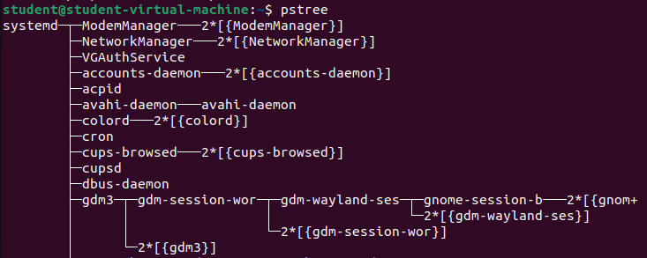

1. **nice-** **nice command** in Linux helps in execution of a program/process with modified scheduling priority. It launches a process with a user-defined scheduling priority. In this, if we give a process a higher priority, then Kernel will allocate more CPU time to that process.

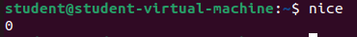

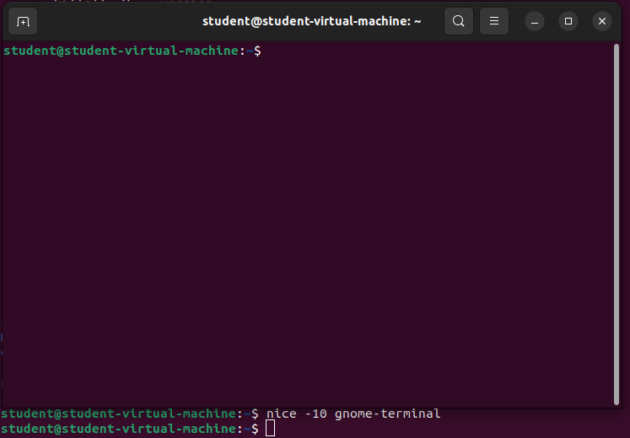

1. **kill-** *kill* command in Linux (located in /bin/kill), is a built-in command which is used to terminate processes manually. *kill* command sends a signal to a process which terminates the process.

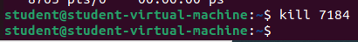

PID 7184 belongs to Mozilla Firefox and it was killed after running kill command.

1. **pkill-** The pkill command uses name of the process instead of PID number. Signal can be send to a process either by typing full name or partial name.



Firefox was killed!

1. **Killall-** This command provides a convenient means of canceling all processes created by the shell that you control. When started by a root user, the killall command cancels all cancellable processes except those processes that started it.



1. **Xkill-** xkill is a command-line utility that can kill the undesired windows on the user's screen. Basically, xkill force the X server to close the connection to the client. This utility kills the programs without providing PID with a command.

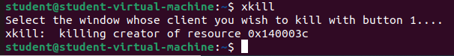

1. **Fg-** Using the fg command to place a job into the foreground removes the job's process ID from the list of those known by the current shell environment.

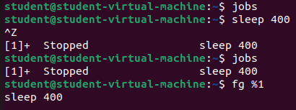

1. **bg-** On Unix-like operating systems, bg is a job control command. It resumes suspended jobs in the background, returning the user to the shell prompt while the job runs. The presence of bg is required for a shell to comply with the POSIX standard.

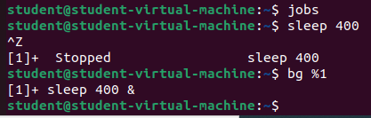

1. **pgrep-** pgrep looks through the currently running processes and lists the process IDs which match the selection criteria to stdout.

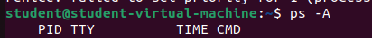





1. **renice-** The renice command allows you to change and modify the scheduling priority of an already running process.

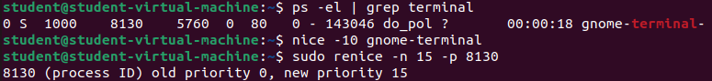

**B) Memory Management**

1. **free-** The free command is used to display the total amount of free and used memory in the system, as well as the amount of memory used by the kernel. It also provides information about the swap space usage in the system.

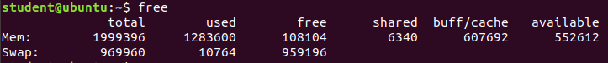

1. **top-** top command is used to show the Linux processes. It provides a dynamic real-time view of the running system. Usually, this command shows the summary information of the system and the list of processes or threads which are currently managed by the Linux Kernel.

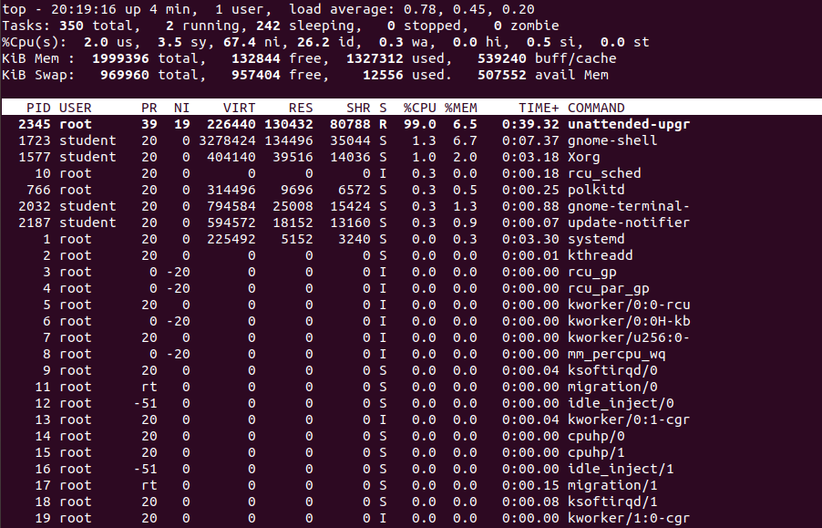

1. **htop-** htop command in Linux system is a command line utility that allows the user to interactively monitor the system’s vital resources or server’s processes in real time. *htop* is a newer program compared to [top](https://www.geeksforgeeks.org/top-command-in-linux-with-examples/) command, and it offers many improvements over top command.

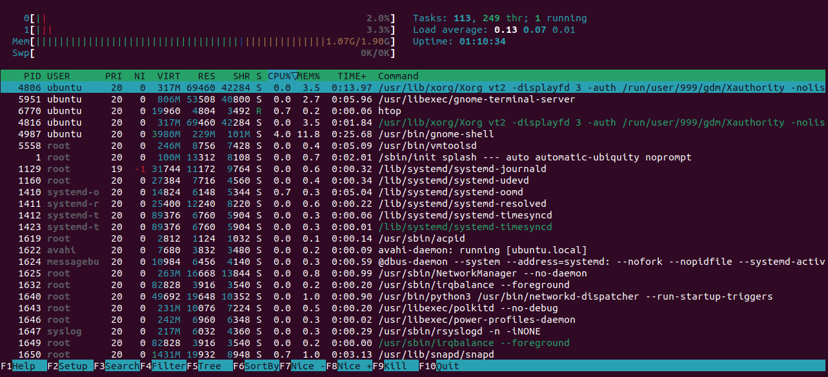

1. **df-** The df command (short for disk free), is used to display information related to file systems about total space and available space.

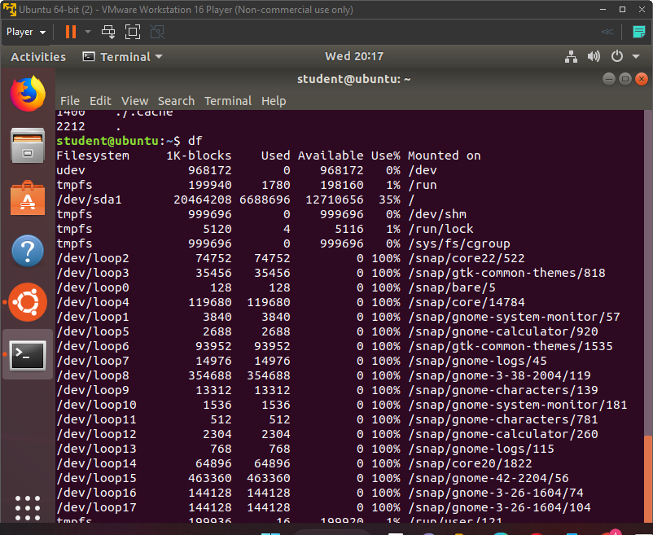

1. **du-** du command, short for disk usage, is used to estimate file space usage.The du command can be used to track the files and directories which are consuming excessive amounts of space on the hard disk drive.

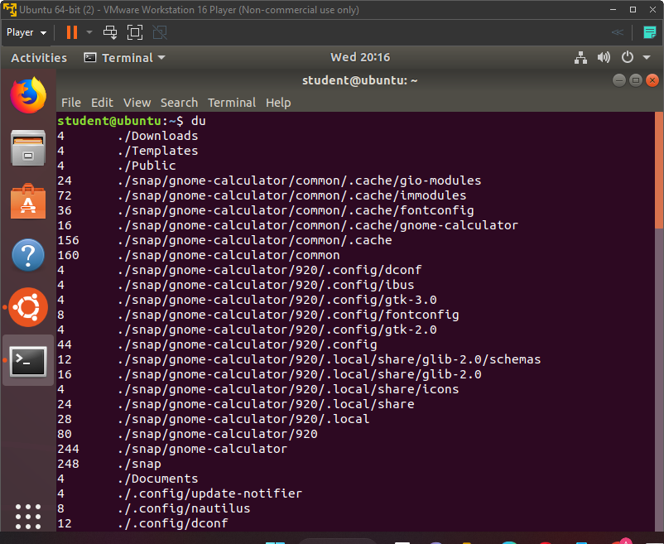

1. **vmstat-** *vmstat* command in Linux/Unix is a *performance monitoring command* of the system as it gives the information about processes, memory, paging, block IO, disk, and CPU scheduling. All these functionalities makes the command *vmstat* also known as *virtual memory statistic reporter*.

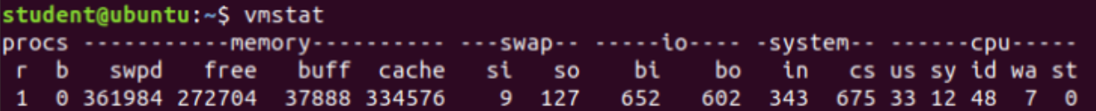

1. **dmidecode-** *dmidecode* also referred as Desktop Management Interface table decoder, record data from DMI table and produce it in human readable format. *dmidecode* command is used when the user want to retrieve system’s hardware related information such as Processor, RAM(DIMMs), BIOS detail, Memory, Serial numbers etc.

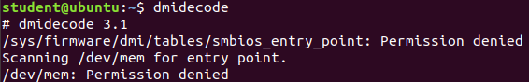

1. **pagesize-** The pagesize command prints the size, in bytes, of a page of memory, as returned by the getpagesize subroutine.

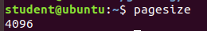

**Shashwat Tripathi**

**D10A 58**

**BATCH C**

**UNIX LAB**

**Experiment No: 2**

**1. Echo:**

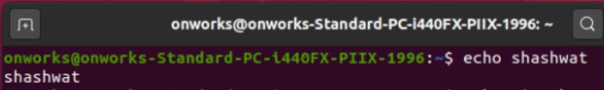

**2. Clear:**

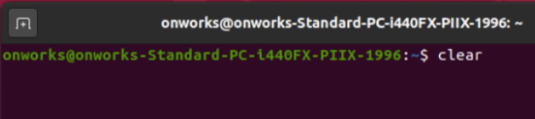

**3. Exit:**

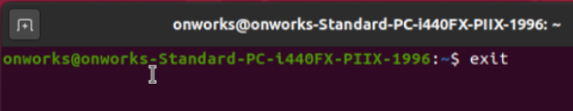

**4.date 5.time 6.uptime 7.cal:**

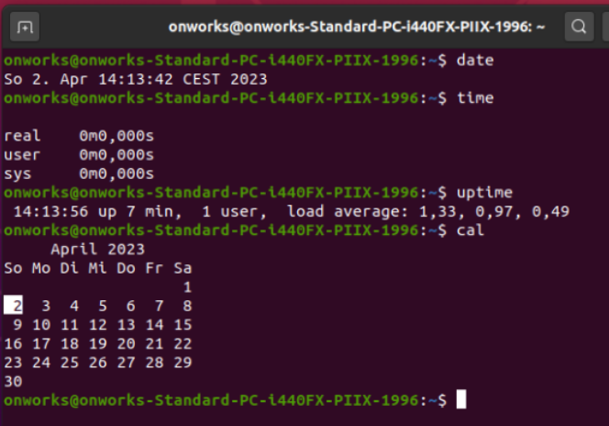

**8.cat:**

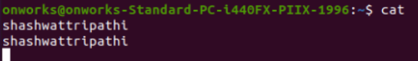

**9.tty:**

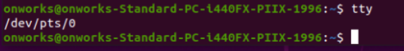

**10.man:**

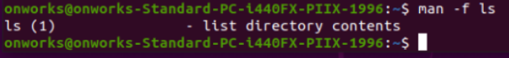

**11.which:**

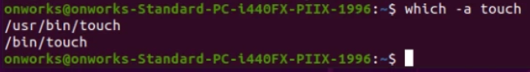

**12.HISTORY:**

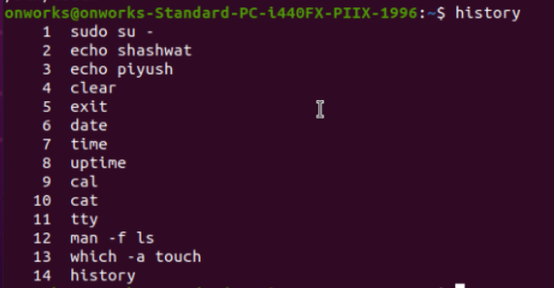

**13.id:**

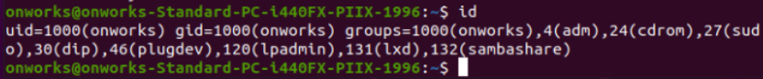

**14.pwd:**

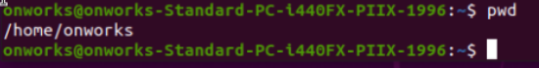

**15.whoami:**



**16.ping:**

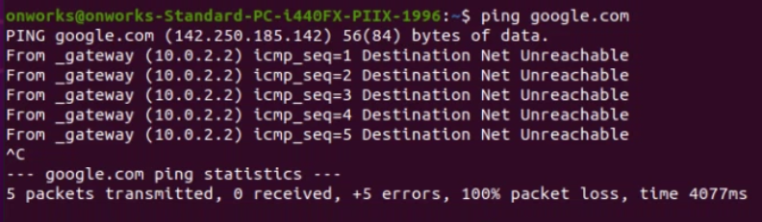

**17.ifconfig:**

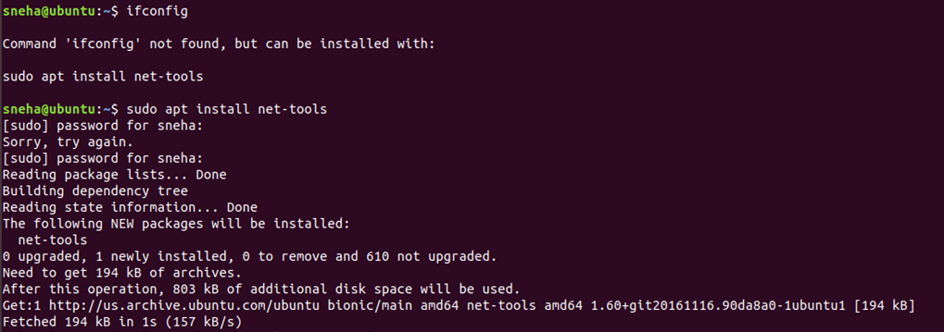

**18.pr:**

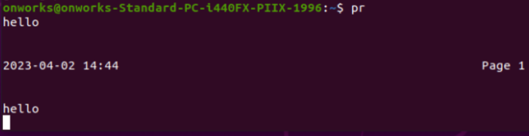

**19.lpstat:**

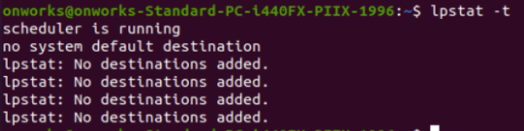

**21.mail:**

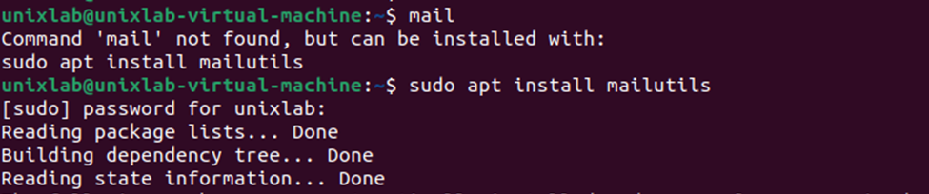

**Shashwat Tripathi**

**D10A 58**

**BATCH C**

**UNIX LAB**

**Experiment No: 3**

**FILE SYSTEM MANAGEMENT SYSTEM COMMANDS:**

**1.ls:lists the contents of a directory.**

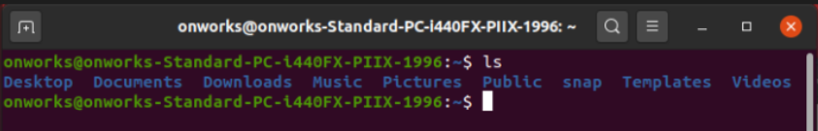

**2. cd: changes the current working directory**



**3. mkdir: changes the current working directory**

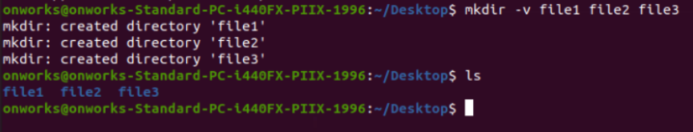

**4. rmdir: removes an empty directory**

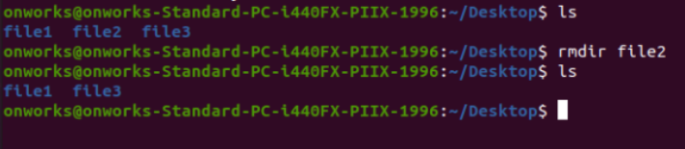

**5.rm: removes one or more files or directories.**

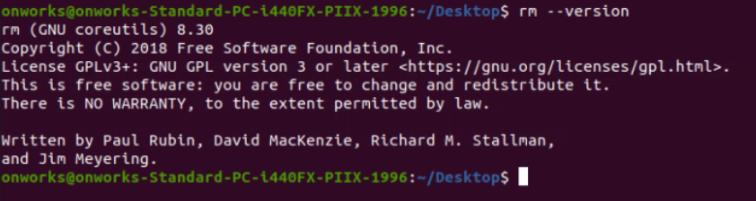

**6.cp: copies files and directories.**

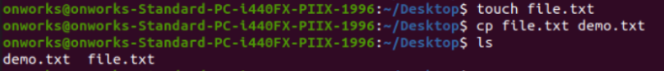

**7.mv: moves or renames files and directories.**

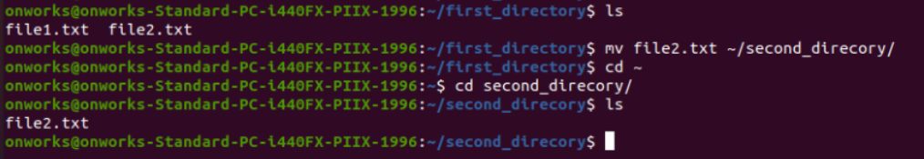

**8.chmod: moves or renames files and directories.**

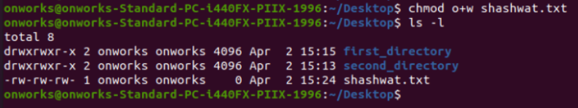

**9.wc:displays the number of lines, words, and characters in a file.**

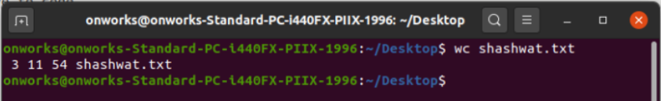

**10.piping and redirection: these allow the output of one command to be passed as**

**input to another command, or to be saved to a file.**

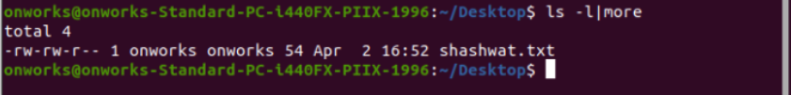

**12. grep: searches for a pattern in one or more files and displays the matching lines.**

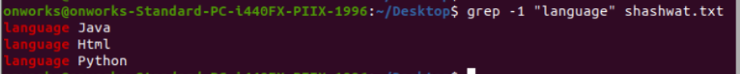

**13. tr:translates or deletes characters.**



**14.sort:sorts the lines of a file.**

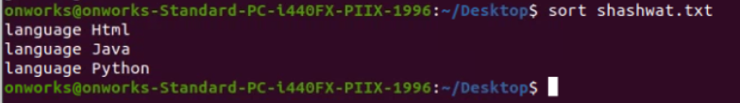

**15.head: displays the first few lines of a file.**

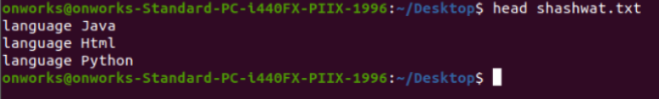

**16.tail:displays the last few lines of a file.**

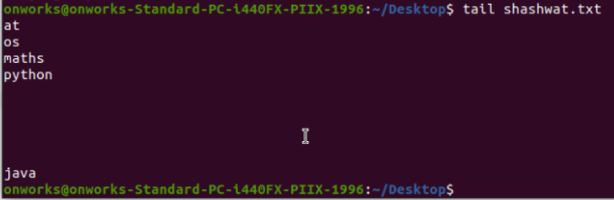

**17. diff:compares the contents of two files and displays the differences.**

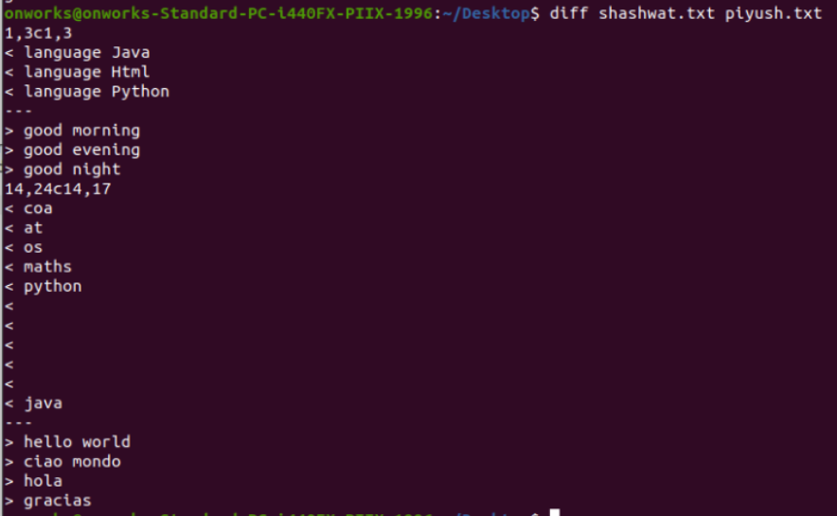

**18.comm:compares the contents of two sorted files.**

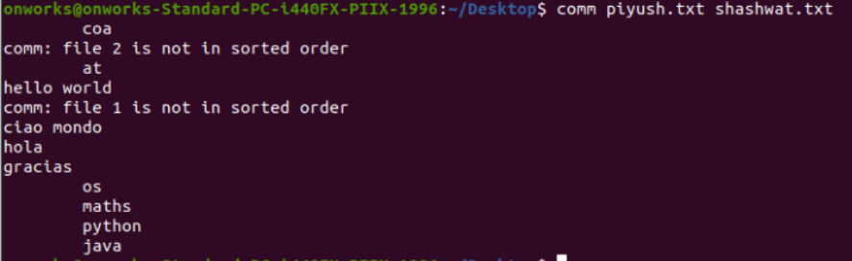

**19. less:allow you to view the contents of a file one page at a time.**

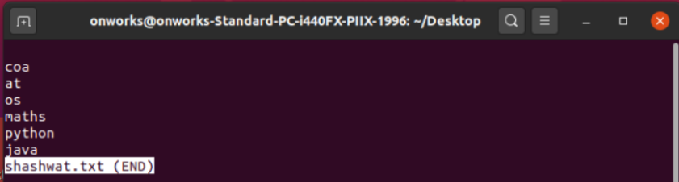

**20.more:allow you to view the contents of a file one page at a time.**

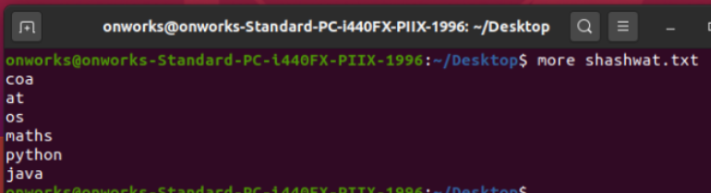

**21.file:allow you to view the contents of a file one page at a time.**

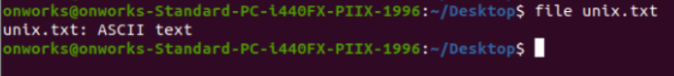

**22. type:displays information about a command, such as its location.**

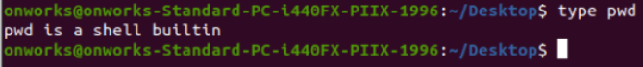

**23. split: splits a file into smaller files**

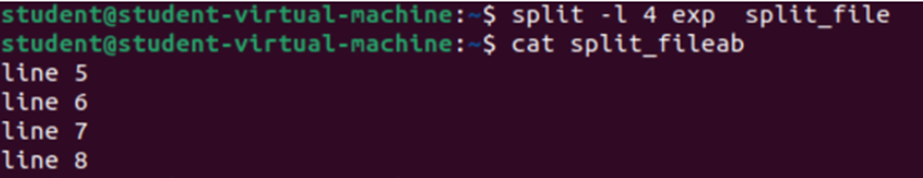

**24.cmp: compares the contents of two files.**



**25.TAR: creates and extracts tar archive files.**

**26.find: searches for files and directories.**



**27.vim: a text editor.**

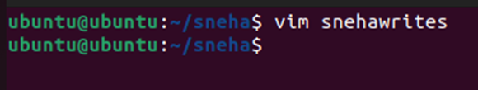

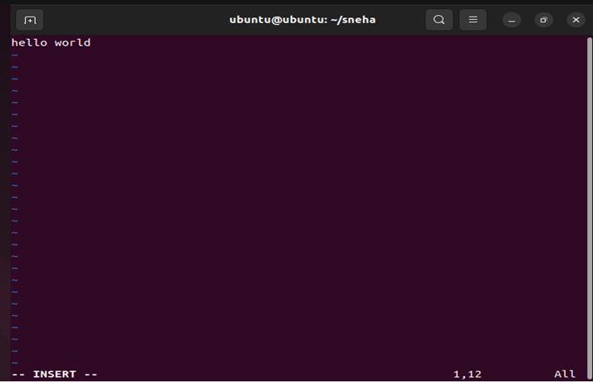

**28.gzip and bzip2: compress and decompress files.**

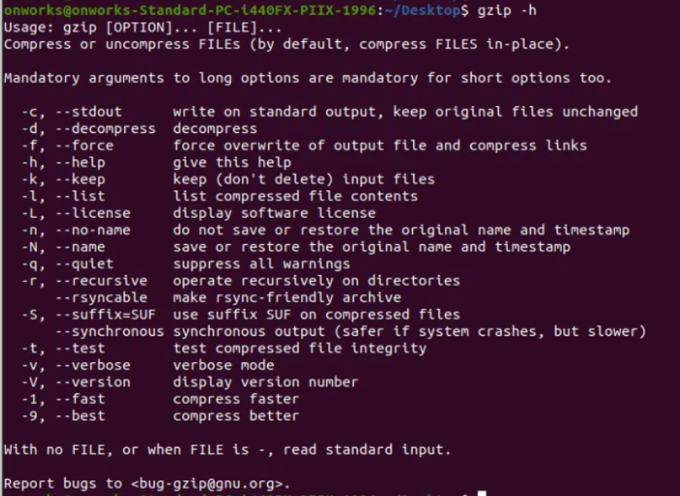

**29.unzip: decompresses files in the ZIP format.**

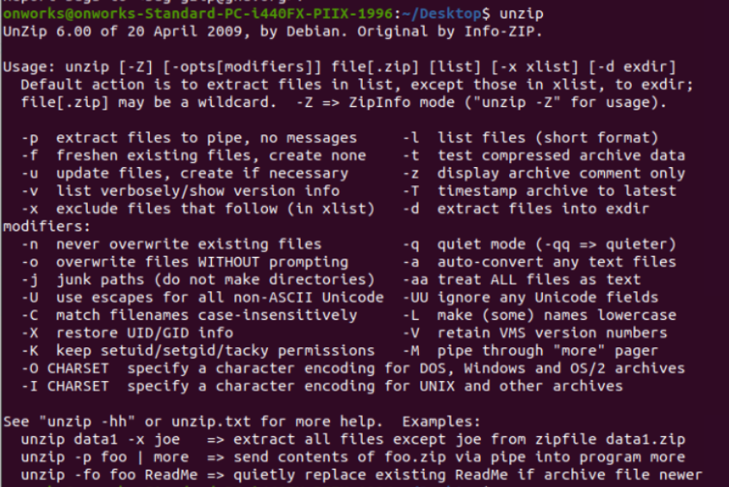

**30.locate: finds files and directories by name.**

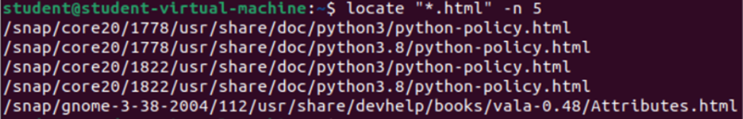

**USER MANAGEMENT COMMANDS**

**1. who:displays information about the users who are currently logged in.**

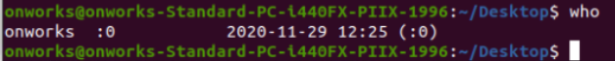

**2. whoami:displays the username of the current user**

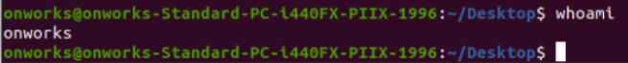

**3. su:switches the current user to another user, typically the superuser (root).**

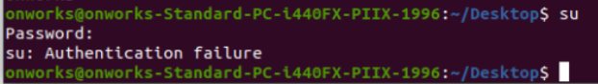

**4. sudo:allows a user to run a command with superuser privileges.**

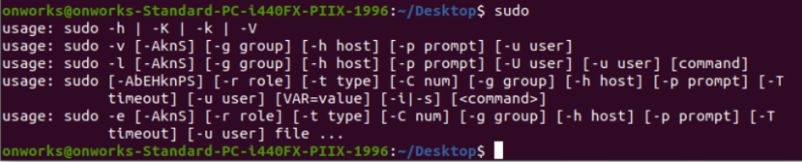

**5. login:logs a user into the system.**

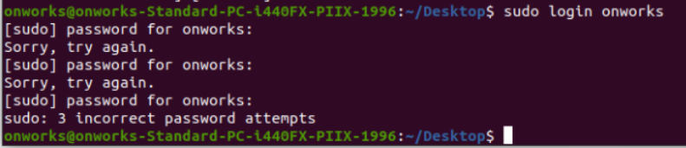

**6.logout or exit: logs a user out of the system**



**7.passwd: changes the password of the current user or another user.**

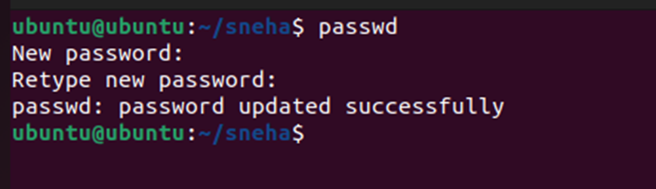

**8.useradd or adduser: adds a new user to the system.**

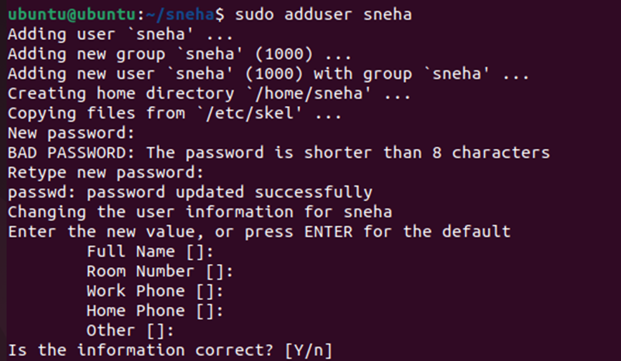

**9.usermod:modifies the attributes of an existing user.**

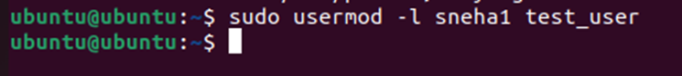

**10.userdel:deletes an existing user.**

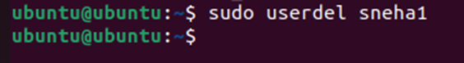

**11.groupadd: adds a new group to the system.**

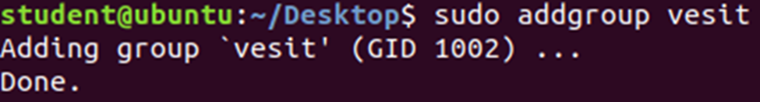

**12.groupmod: modifies the attributes of an existing group.**



**13.groupdel: deletes an existing group.**



**14.gpasswd: changes the password of a group.**

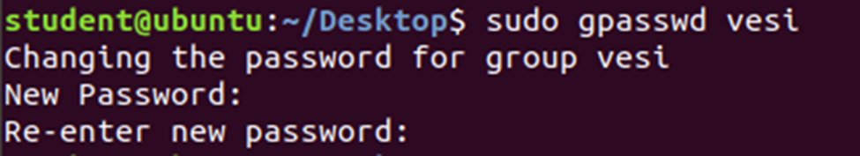

**15.chown: changes the owner of a file or directory.**

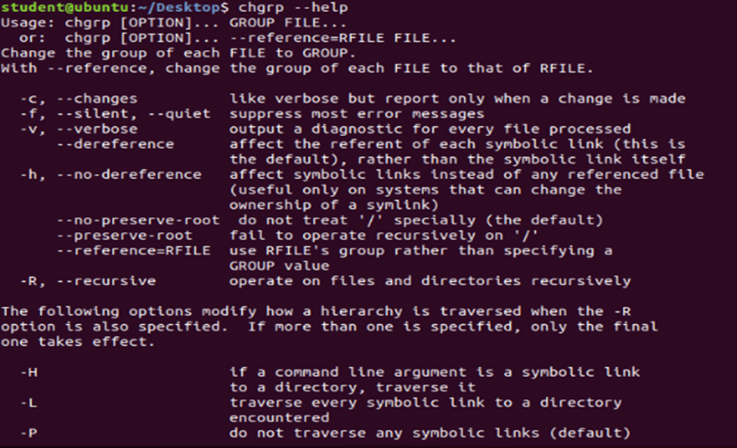

**16)chage: changes the password aging information for a user.**



**17)chgrp: changes the group ownership of a file or directory.**



**18)chfn: changes the information about a user, such as the full name and office**

**location.**

